**Description**

As a user I must have ability to navigate between Home ,Menu, Contact, Store info.

------------------------------------------------------------------------------------------------------------------------------------------

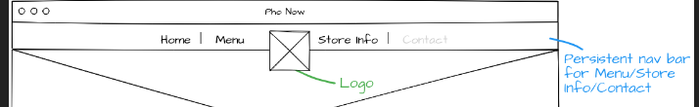

**Acceptance criteria**

* Home option is selected by default on login
* All options are always available .